

# KOLEJ PROFESIONAL MARA BERANANG DIPLOMA IN COMPUTER SCIENCE

**COURSE NAME** : **MOBILE APPLICATION DEVELOPMENT**

# COURSE CODE : CSC2813

**ACADEMIC SESSION** : **1 2024/2025**

# TYPE OF ASSESSMENT : ASSIGNMENT

**DURATION** : **18/06/2024 – 02/07/2024**

**CLO3:**Demonstrate entrepreneurial skills in promoting mobile application at any platform. (A3, PLO10)

# INSTRUCTION TO CANDIDATES:

1. Late submissions after given due date will not be accepted.
2. Report should be written using: Font type: Arial

Size: 11 pts

Line Spacing: 1.5

|  |  |
| --- | --- |
| **Personal Details** | |
| **Name** | MUHAMMAD EQMAL BIN NOOR RANIZ |
| **I/D Number** | BCS2211-026 |
| **Class** | DCS 5B |
| **Lecturer** | PUAN FAZLIANI |

|  |  |
| --- | --- |
| **Section / Question No.** | **Marks** |
| Task 1 | /5 |
| Achievement | /20 |
| Entrepreneurial Opportunity | /5 |
| Creativity | /16 |
| Entrepreneurial Experience (Engagement) | /4 |
| **Total** | **/50** |

# Scenario

Social media refers to online platforms and websites that enable users to create and share content, engage with others, and participate in social networking. Social media has become a powerful tool for entrepreneurship, offering various benefits for businesses and individuals looking to promote their products or services, build their brand, connect with customers, and grow their audience.

This assignment aims to leverage social media for promoting the product in entrepreneurship, contributing to the evolution of modern marketing practices and empowering businesses to achieve effective promotion.

# Task:

* 1. Illustrate paper wireframes of your project that adhere to industry standards.
  2. Create an online markting strategy and spread it on social media platforms which are

**TikTok** and **Instagram** in order to promote the brand of your product.

* 1. Produce a complete report that contains online promotion of your product.
  2. Demonstrate your entrepreneurial skills in doing online promotion based on all the requirements stated in ‘Individual Project Evaluation Rubric’ form as attached.
  3. The content of your report should include:
     1. Wireframe.
     2. Username of TikTok account.
     3. Username of Instagram account.
     4. Screenshots of all requirements stated in ‘Individual Project Evaluation Rubric’ form (maximum 3 screenshots per page).
     5. Explanation for each screenshot.

**Assessment Rubric Task 1:**

|  |  |  |  |  |
| --- | --- | --- | --- | --- |
| **TASK** | | **MARKS** | | **MARKS OBTAINED** |
| 1 | Illustrate paper wireframes for your project | □ Wireframe should be complete representation of the whole apps that support user goals. | **1** |  |
| □ Clearly shows the basic structure of the page including elements like navigation, buttons, images and text for the whole wireframe. | **1** |  |
| □ Clearly applied visual hierarchy with the representation of layout and structure for the whole wireframe. | **1** |  |
| □ Put strong focus on the order of information. | **1** |  |
| □ Apply appropriate design patterns for the whole pages. | **1** |  |

**INDIVIDUAL PROJECT EVALUATION RUBRIC**

**CLO3: DEMONSTRATE ENTREPRENEURIAL SKILLS IN PROMOTING MOBILE APPLICATION AT ANY PLATFORM (A3, PLO 10)**

|  |  |  |  |  |  |  |  |  |
| --- | --- | --- | --- | --- | --- | --- | --- | --- |
| **Attribute** | **Subattribute** | **Criteria** | **Very weak**  **1** | **Weak**  **2** | **Satisfaying**  **3** | **Good**  **4** | **Very Good**  **5** | **Marks** |
|  |  | TikTok Followers | Able to acquire 1-10 followers | Able to acquire 11 – 30 followers | Able to acquire 31 – 60 followers | Able to acquire 61 – 100 followers | Able to acquire 101 followers and above |  |
|  |  | TikTok Posting Likes | Able to acquire 1-10 likes | Able to acquire 11 – 30 likes | Able to acquire 31 – 60 likes | Able to acquire 61 – 100 likes | Able to acquire 101 likes and above |  |
|  | **Achievement** |  |  |  |  |  |  |
| Instagram Followers | Able to acquire 1-10 followers | Able to acquire 11 – 30 followers | Able to acquire 31 – 60 followers | Able to acquire 61 –100 followers | Able to acquire 101 followers and above |  |
|  |  | Instagram Posting Likes | Able to acquire 1-10 likes | Able to acquire 11 – 30 likes | Able to acquire 31 – 60 likes | Able to acquire 61 – 100 likes | Able to acquire 101 likes and above |  |
|  | **Entrepreneurial Opportunity** | HASHTAG  Ability to use the correct hashtag on the bio profile or each uploaded image.  Trendy : example #allstartgv General : example #alhamdulillah.  Unique : hashtag created by itself, such as from its name or brand. | Unable to use the correct Hashtag on the bio profile or every uploaded image (eg.: Trendy, General and Unique). | Able to use hashtag on the bio profile only. | Able to use slightly the correct Hashtag on the bio profile or only a few uploaded images (eg.: Trendy, General and Unique). | Able to use the correct Hashtag on the bio profile or every uploaded image (eg.: Trendy, General and Unique) but inadequate compulsory Hashtag. | Able to use the correct Hashtag on the bio profile or every uploaded image (eg.: Trendy, General and Unique)  The unique hashtags represent the app or company. |  |
|  |  | TIKTOK ACCOUNT  Ability to create TikTok account with attractive layout and format as well as complete  business information. | Able to create TikTok account. | Able to create TikTok account but lacks of business information. | Able to create TikTok account with complete business information which are business name, bio, contact information and profile picture. | Able to create TikTok account with complete business information which are business name, bio, contact information and profile picture. |  |  |
|  |  |  |  |  |  | TikTok have link to allow potential customer directly contact the owner. |
| **ENTREPRENEURSHIP SKILLS** |  | TIKTOK CONTENT  Ability to create creative and engaging content by effectively utilizing visual elements such as effects, filters, transitions. | Unable to create creative and engaging content using visual elements (effects, filters, transitions) in any posts. | Able to create creative and engaging content by effectively utilizing visual elements (effects, filters, transitions) in at least **TWO**  **(2)** posts. | Able to create highly creative and engaging content by effectively utilizing visual elements (effects, filters, transitions) in at least **THREE (3)** posts. | Able to create highly creative and engaging content by effectively utilizing visual elements (effects, filters, transitions) in at least **FOUR (4)** posts. |  |  |
|  | **Creativity** |  |  |  |  |  |  |  |
|  |  | INSTAGRAM COPYWRITING: SOFT SELL  Ability to do soft sell copywriting. | Able to do 1 – 2 posts using the correct soft sell technique – Title – Introduction of story – Storytelling – CTA | Able to do 3 – 4 posts using the correct soft sell technique – Title – Introduction of story – Storytelling – CTA | Able to do 5 – 6 posts using the correct soft sell technique – Title – Introduction of story – Storytelling – CTA | Able to do 7 posts and more using the correct soft sell technique –  Title – Introduction of story – Storytelling  – CTA |  |  |
|  |  |  |  |  |  | All posts must be linked with the TikTok page. |
|  |  | ATTRACTIVE PICTURE  The uploaded picture must be interesting in terms of background, props used, lighting and rules of third. | Able to upload interesting images. (3 pictures) | Able to upload interesting images. (6 pictures) | Able to upload images that are interesting in terms of backgrounds, props, lighting, and rules of the third.  (15 pictures) | Able to upload images that are interesting in terms of backgrounds, props, lighting, and rules of third  (20 pictures and above). |  |  |
|  |  |  |  |  |  | The photos are creatively design and interesting. |
|  | **Entrepreneurial Experience (Engagement)** | Instagram: CALL TO ACTION  Ability to create a Call to Action (CTA) in every posting.  [Insert CTA like phone number, email address, TikTok link or Website link] | Able to create CTA but only provide **ONE (1)** of the following below in all posting:  Phone Number  Email Address  TikTok Link  Website Link | Able to create CTA but only provide **TWO (2)** of the following below in all posting:  Phone Number  Email Address  TikTok Link  Website Link | Able to create CTA but only provide **THREE(3)** of the following below in all posting:  Phone Number  Email Address  TikTok Link  Website Link | Able to create CTA by providing **ALL** of the following below in all posting:  Phone Number  Email Address  TikTok Link  Website Link |  |  |
| **TOTAL** | | | | | | | | **/50** |
| **TOTAL FINAL MARKS (35%)** | | | | | | | |  |

**NOTE :**

For subattribute achievement,

* + - 1. TikTok posting likes, number of likes refering to total number of likes for all.
      2. Instagram posting likes, number of likes refering to total number of likes for all.

TABLE CONTENTS

1.WIREFRAME OF THE PROJECT

1.1 Login Page

1.2 Register Page

1.3 Main Screen

1.4 Upload Screen

1.5 Admin Page

1.6Update Admin Page

2.TikTok

2.1 TikTok Name

2.2 TikTok Post and Explanation

3.Instagram

3.1 Instagram Name

3.2 Instagram Post and Explanation

***TASK 1: WIREFRAME OF THE PROJECT***

**1.1: Login Page**

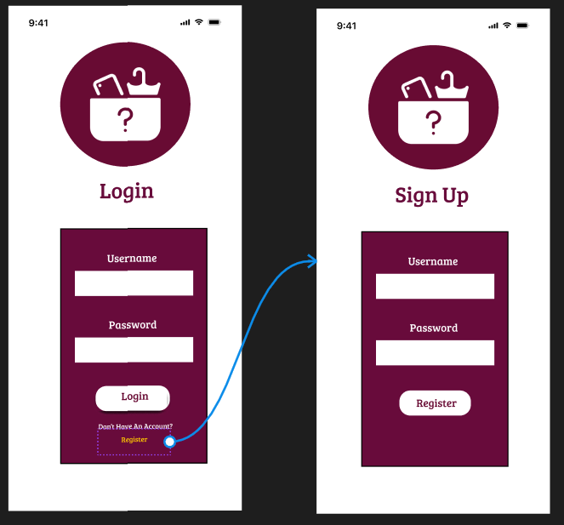

This Is the First Page That User Will See. Users Will Enter Their Credentials or If They Don’t Have An Account, They Can Simply Press On The Register Button At The Bottom Of The Page That Will Redirect User To The Register Page.

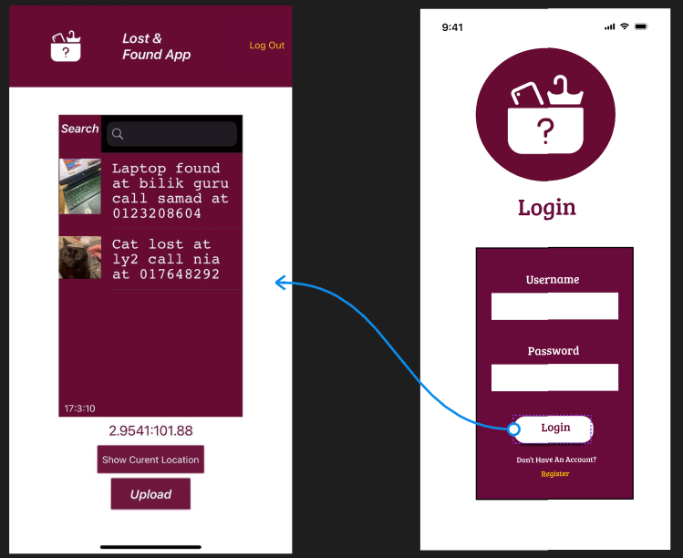

When The User Successfully Enter the Verified Credentials, User Will Be Redirected To The Main Page Of The App.

S

**1.2 Register Page**

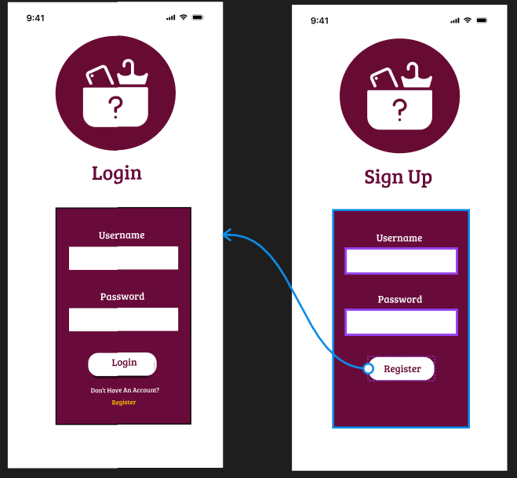

When User Click on Register Button at The Login Page They Will Be Redirected To The Register Page. Users Will Enter Their Desired Credentials at The Register Page And Will Click On The Register Button When They Are Satisfied Or Sure With Their Credentials. When The User Successfully Registered User Wil Redirected to The Login Page Again to Enter Their Registered Credentials Earlier.

**1.3 Main Screen**

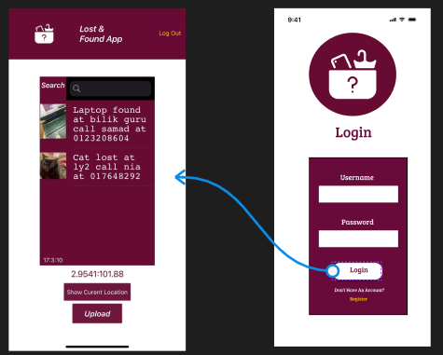

When User Have Successfully Log In With Their Verified Credentials They Will Be Redirected To The Main Page Where They Can See The List Of The Lost Item.

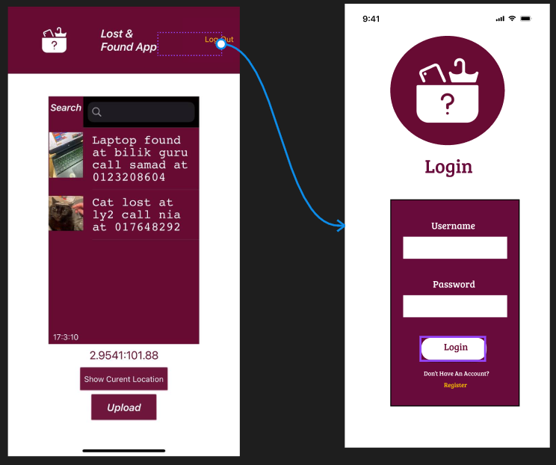

When User Doesn’t Want To Use The App Anymore They Can Simply Press The Log Out Button And It Will Redirect User To The Login Page Back.

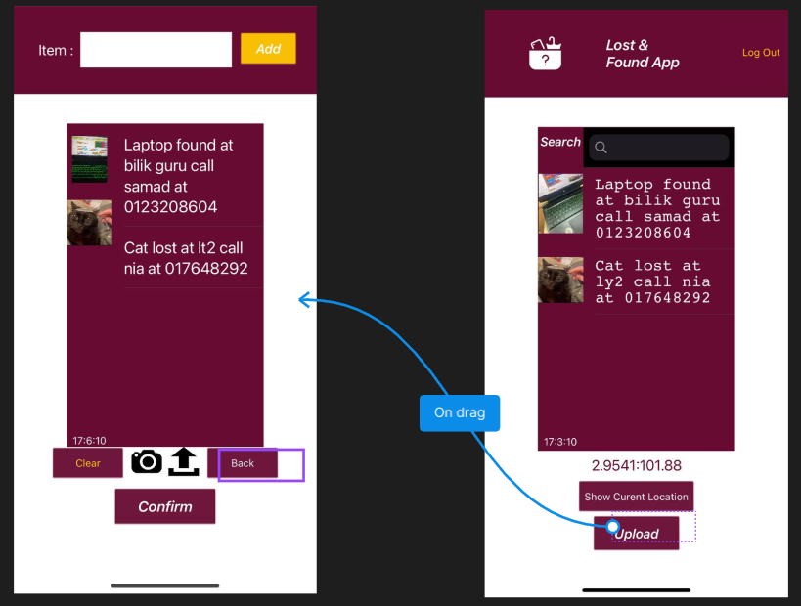

When User Want to Report the Missing Item That They Found They Can Simply Press the Upload Button At The Bottom Of Th Page And It Will Redirect User To The Upload Page. If a User Doesn’t Know Time, They Can Simply See It at The Bottom Left of The Page and If They Want To Know Their Current Location They Can Simply Press On The Show Current Location Button And It Will Display The Current Location Of The User.

**1.4 Upload Screen**

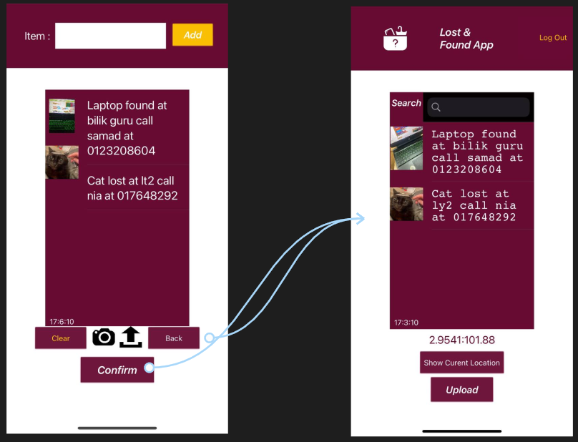

When User Want to Take A picture Of the Item, They Can Simply Press the Camera Button and It Will Open Camera To Let The User Capture Picture Of The Item. If User Already Have the Picture, They Can Simply Click on The Upload Button And It Will Open User Gallery. After User Have Chosen The Picture, It Will display The Picture At The Upload Page. After the User Have Taken or Choose Picture User Will Enter The Detail At The Top Of The Page And If They Have Satisfied With The Detail They Will Simply Click On Add Button And It Will add The Detail Beside The Picture. When User Want to Cancel the Report, They Can Simply Click On Clear Button That Will Clear The List. If They Miss click To The Upload Page They Can Simply Click On The Back Button And It Will Redirect User To The Main Page Back. If User Want to Submit The Report, They Will Simply Click On Confirm Button And It Will Post The Report At The Main Page Thus Redirect User To The Main Page Back.

**1.5 Admin Page**

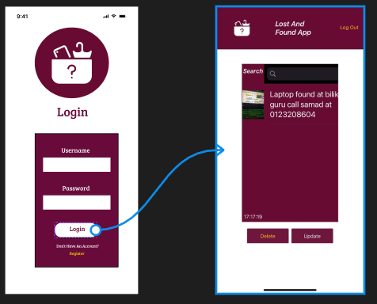

When Admin Have Correctly Enter the Unique Username and Password That Made Only for The Administer It Will Redirect Admin to The Admin Main Page.

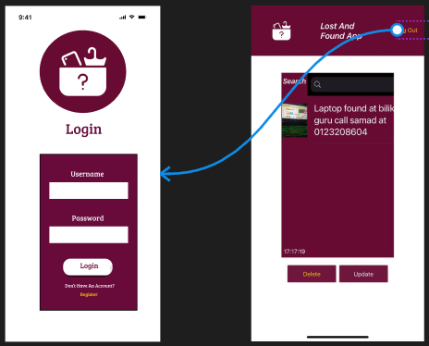

If The Admin Wants to Log Out, They Can Simply Click on The Log Out Button and It Will Redirect to The Login Page Back.

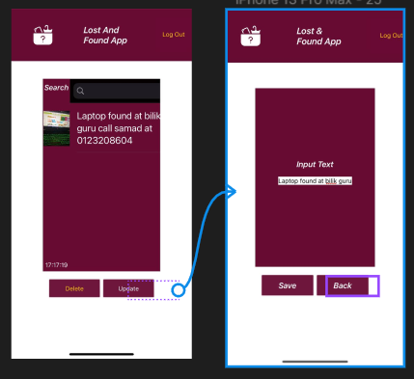

When Admin Wants to Delete the Report That Already Been Claimed or Fake Report They Will Simply Click on The Report and Click on The Delete Button and The Report Will Be Deleted. If They Want to Configure or Adjust the Report They Will Click on The Report and Press the Update Button and It Will Redirect Them to The Update Page.

**1.6: Update Admin Page**

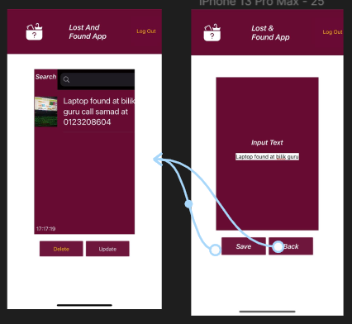

When The Admin Have Made the Change for The Report, They Will Simply Press on Save Button and It Will Redirect Them To The Admin Main Page With The Edited Report. If They Have Miss click The Upload Page They Can Simply Click On Back Button And Will Redirect Back To The Admin Main Page.

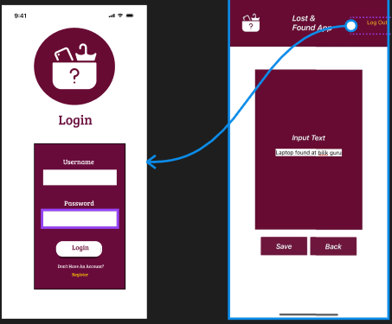

If Admin Done with Their Work, They Can Simply Press on The Log Out Button and Will Redirect Them to The Log in Page Back.

**2.TIKTOK**

**2.1 TikTok Name**

Name: lostfoundapp

Call: 015-6737-486

Email: lost&found@gmail.com

Website: [www.lost&found.com](http://www.lost&found.com)

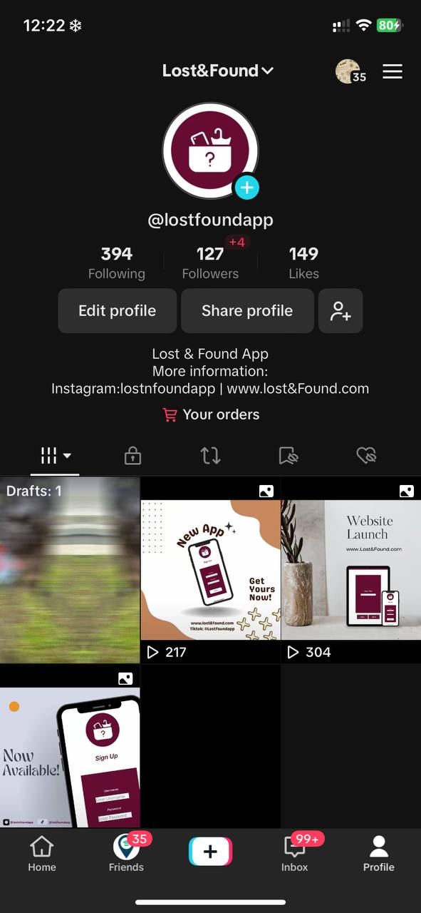

**2.2 TikTok Post and Explanation**

First Post

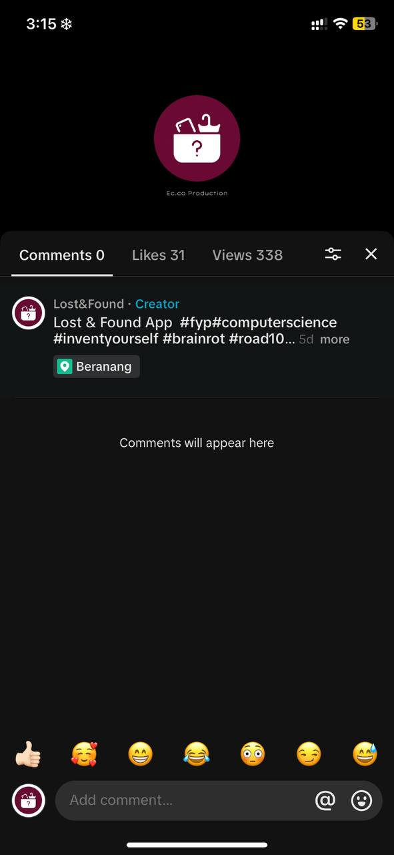



This is my first post on TikTok using my app.In just a few seconds, this video introduces the viewer to my app. I utilize a variety of hashtags to draw viewers to my videos or to advertise them on the "For You Page" on Tiktok. In some of them, I use computer science to indicate that the app is related to computer science, and the phrase "invent yourself" refers to my own creation of the app.

Second Post

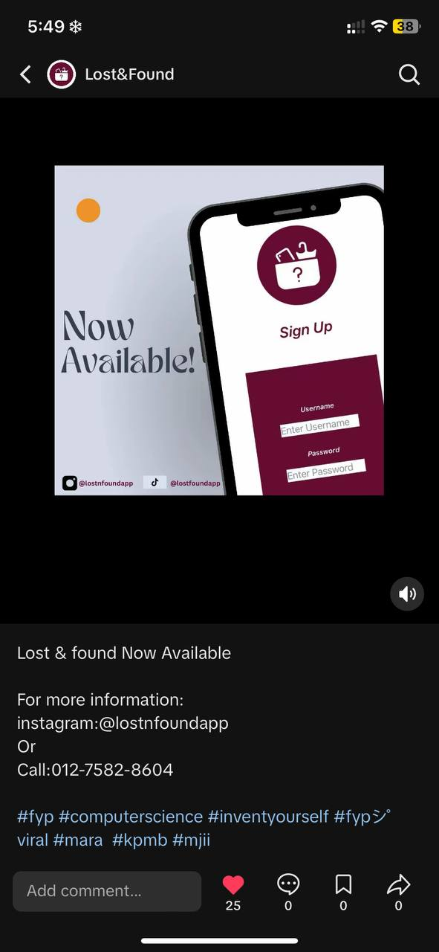

Using my TikTok app, this is my second post. This post demonstrates that my app is already available for users to use or download. I also used a variety of hashtags in my post, one of which is fyp, which stands for you page. I utilize this hashtag to post to the TikTok users and advertise my app.I also include more information in the post so that users who are interested in my app can contact me with any questions they may have.

Third Post

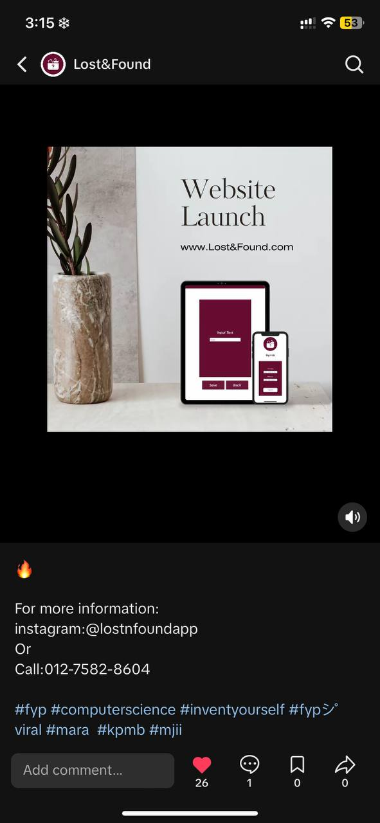

Using the TikTok app, this is MY third post. This post demonstrates that my app has a personal website and that it was just released. With this announcement, users can visit the website to learn more about the app or how to utilize it.I use a variety of hashtags as well; kpmb is one of them. For our college, Kolej Professional Mara, KPMB stands out. I may tell the student KPM that I made this app or promote it with this hashtag.so that if the kid finds or loses something they want, they can use this app.In the event that you have any questions concerning the app, I also provide more information.

Fourth Post

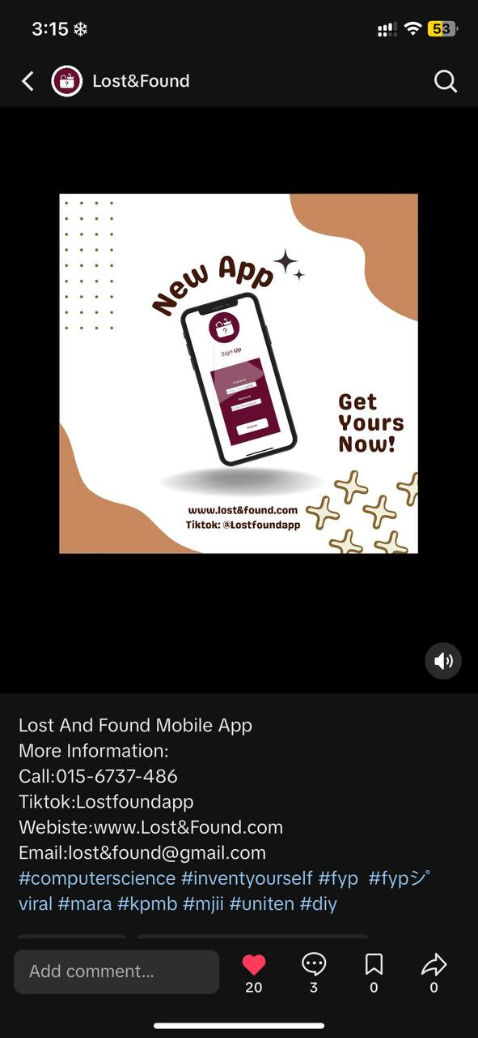

This is my fourth post on TikTok, and it serves to inform readers about a new app that has just been released on the playstore and app store. The purpose of this post is to advertise the app to Android or iPhone users. In case the audience has any questions about the app, I also provide them with more information. I employ a variety of hashtag methods, and DIY and viral are two of them. DIY means for do it yourself, and viral indicates that this app is likely to become well-known and popular soon.

**3.INSTAGRAM**

**3.1 Instagram Name**

Name: lostnfoundapp

Call: 015-6737-486

Email: lost&found@gmail.com

Website: [www.lost&found.com](http://www.lost&found.com)

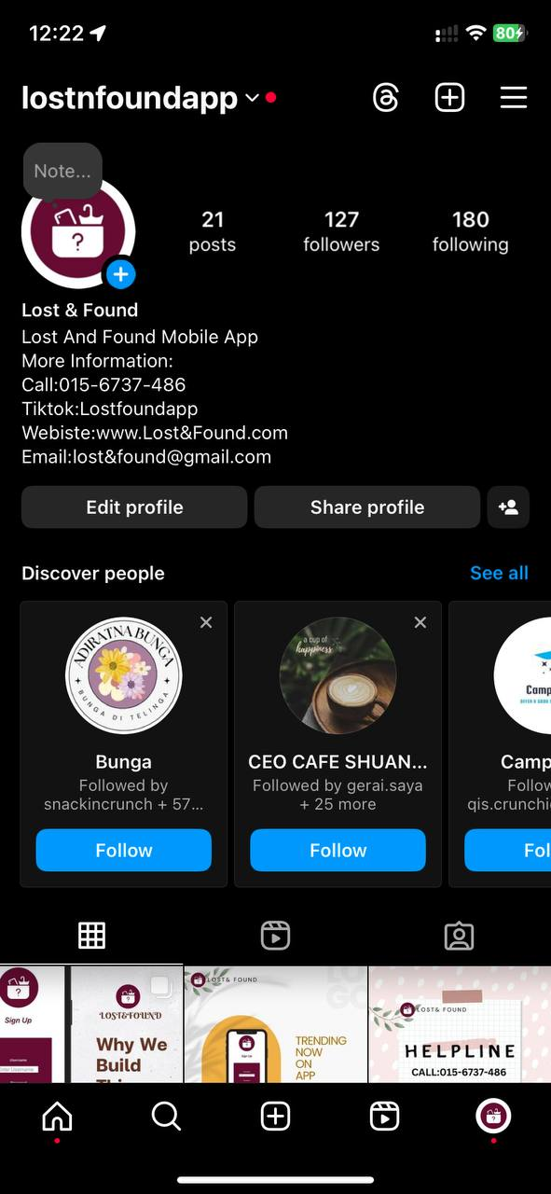

**3.2 Instagram Post and Explanation**

First Post

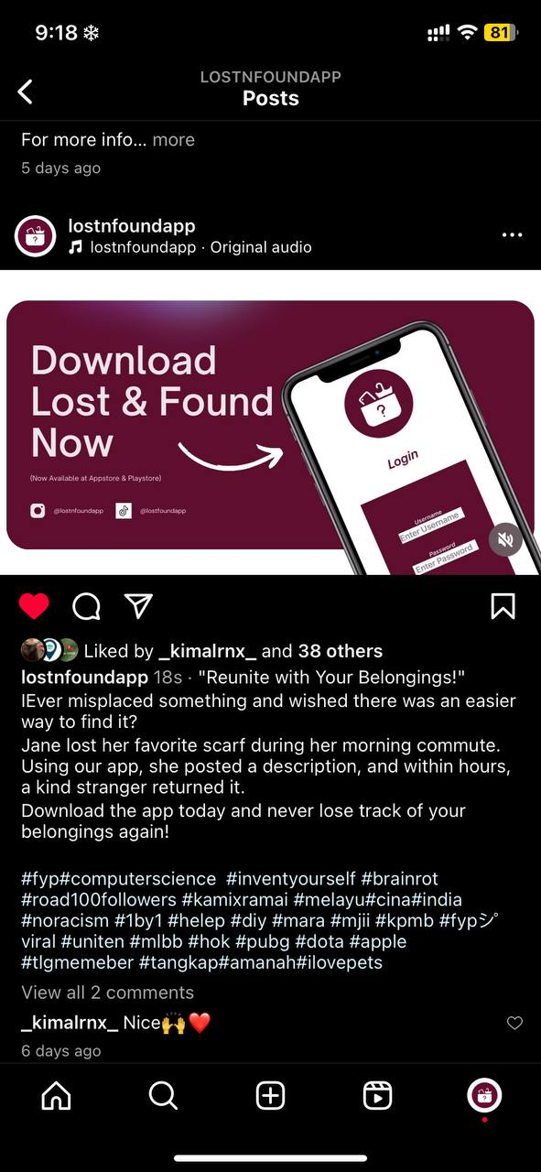

This is my first post on Instagram using my app.In just a few seconds, this video introduces the viewer to my app. I utilize a variety of hashtags to draw viewers to my videos or to advertise them on the "For You Page" on instagram. In some of them, I use computer science to indicate that the app is related to computer science, and the phrase "invent yourself" refers to my own creation of the app.

Second Post

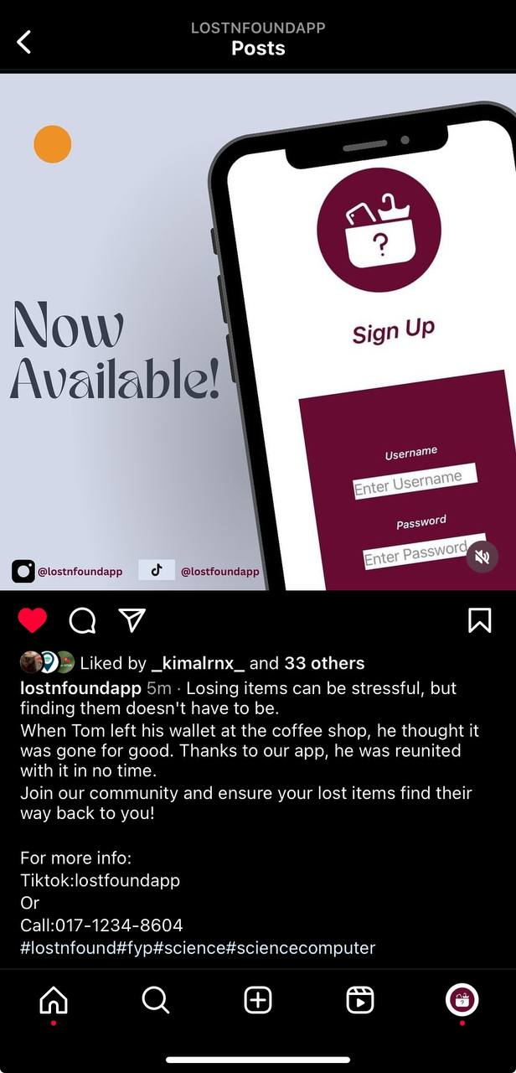

Using my Instagram app, this is my second post. This post demonstrates that my app is already available for users to use or download. I also used a variety of hashtags in my post, one of which is fyp, which stands for you page. I utilize this hashtag to post to the Instagram users and advertise my app.I also include more information in the post so that users who are interested in my app can contact me with any questions they may have.

Third Post

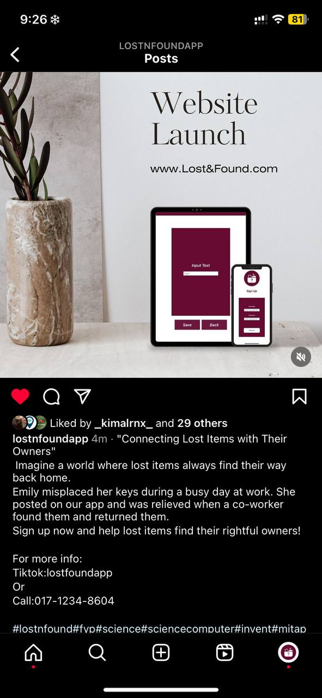

Using the Instagram app, this is My third post. This post demonstrates that my app has a personal website and that it was just released. With this announcement, users can visit the website to learn more about the app or how to utilize it.I use a variety of hashtags as well kpmb is one of them. For our college, Kolej Professional Mara, KPMB stands out. I may tell the student KPM that I made this app or promote it with this hashtag.so that if the kid finds or loses something they want, they can use this app.In the event that you have any questions concerning the app, I also provide more information.

Fourth Post

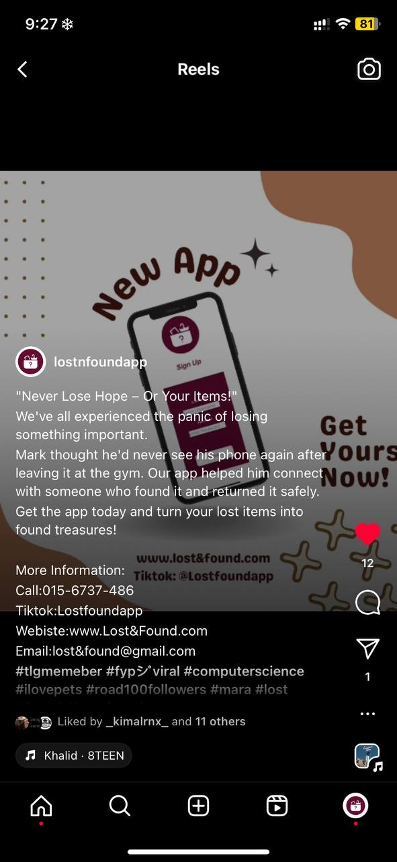

This is my fourth post on Instagram, and it serves to inform readers about a new app that has just been released on the playstore and app store. The purpose of this post is to advertise the app to Android or iPhone users. In case the audience has any questions about the app, I also provide them with more information. I employ a variety of hashtag methods, and DIY and viral are two of them. DIY means for do it yourself, and viral indicates that this app is likely to become well-known and popular soon.

Fifth Post

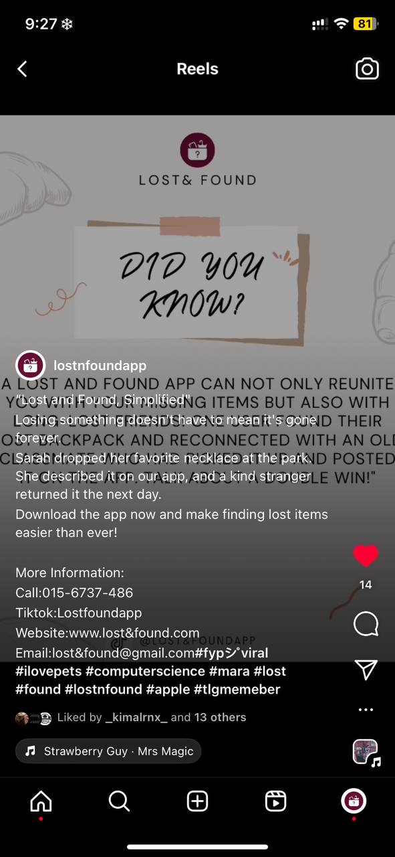

This is my fifth Instagram post, where I share a fun titbit about my lost-and-found app. With this interesting fact, users' knowledge may grow and they may become more interested in using the software. In order to promote the app, I also utilize a variety of hashtags. One of them, lost & found, attracts users who were looking for an app that uses the hashtag.

Sixth Post

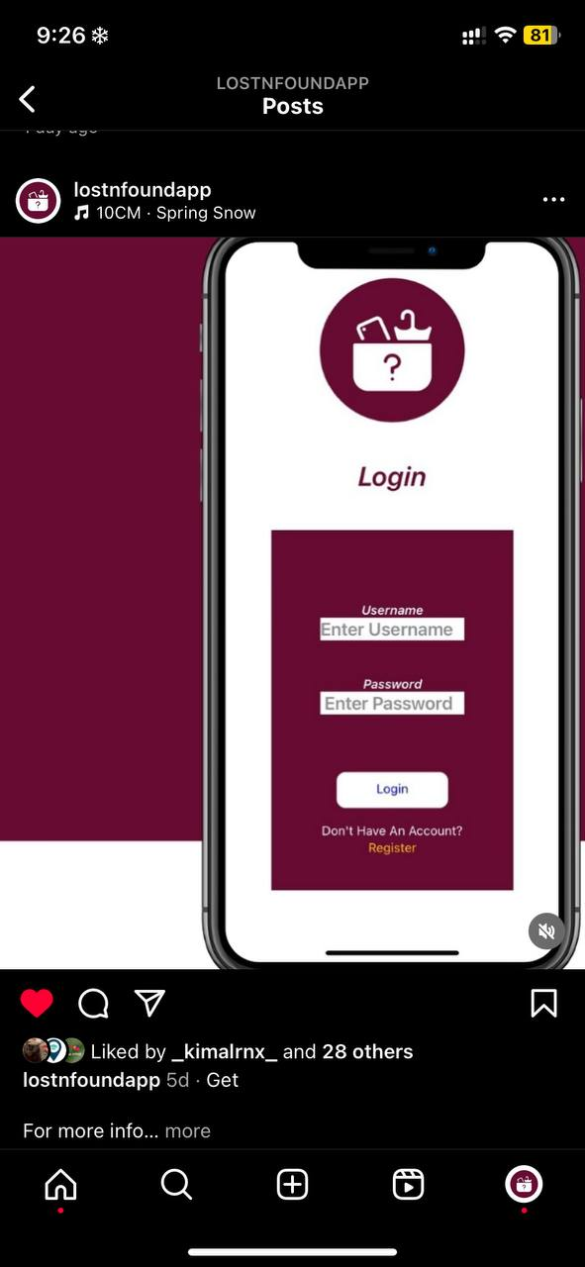

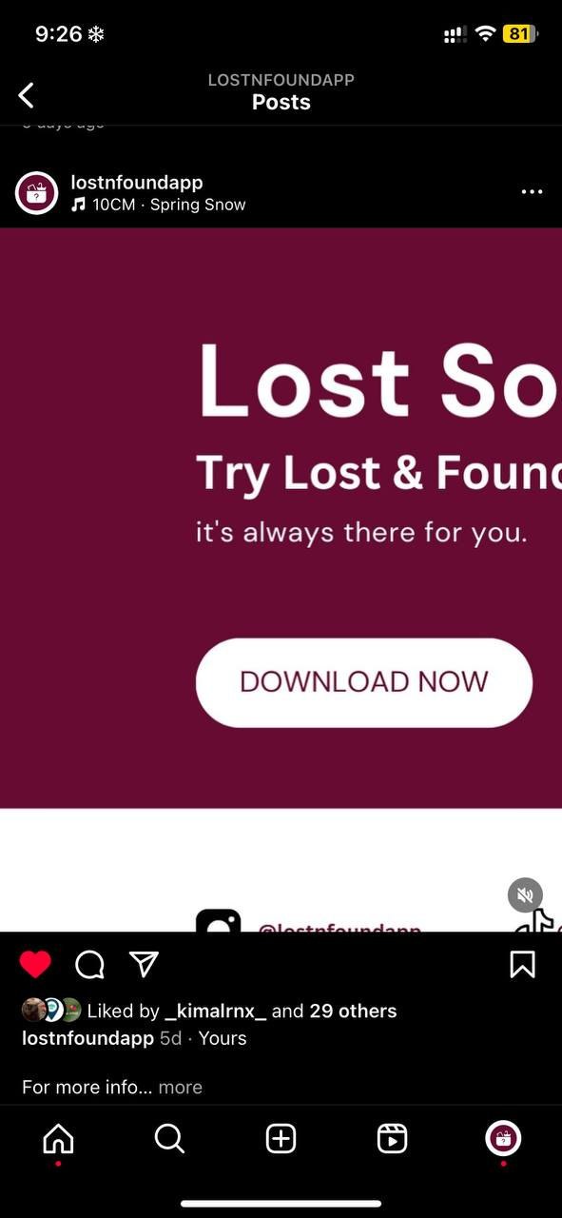

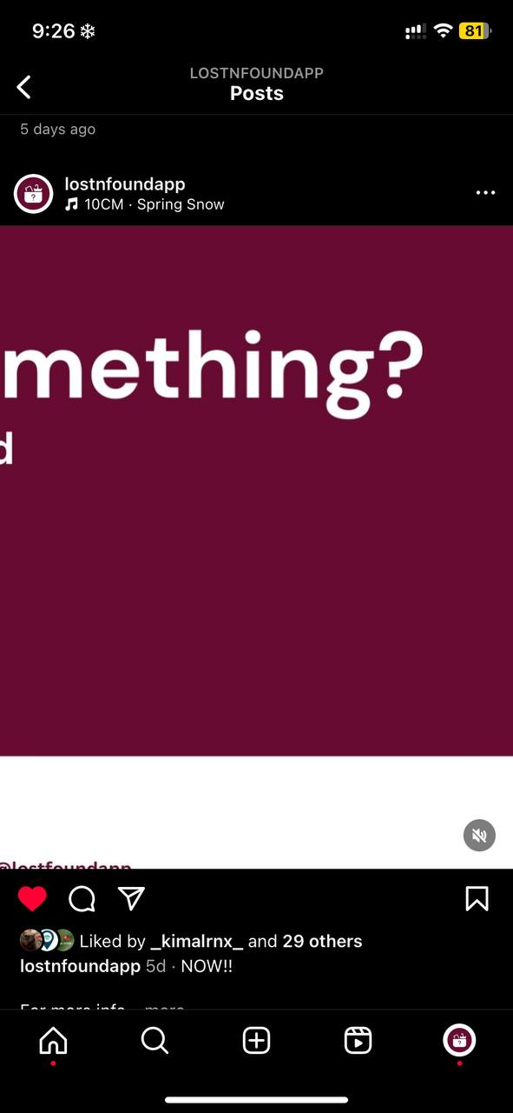

This is my sixth Instagram post, where I'm promoting my app. Instagram users may occasionally notice this kind of advertisement and find it interesting. I also included a variety of hashtags, and the one I highlighted was for my app, Mit App, which is the platform on which I developed it.

Seventh Post

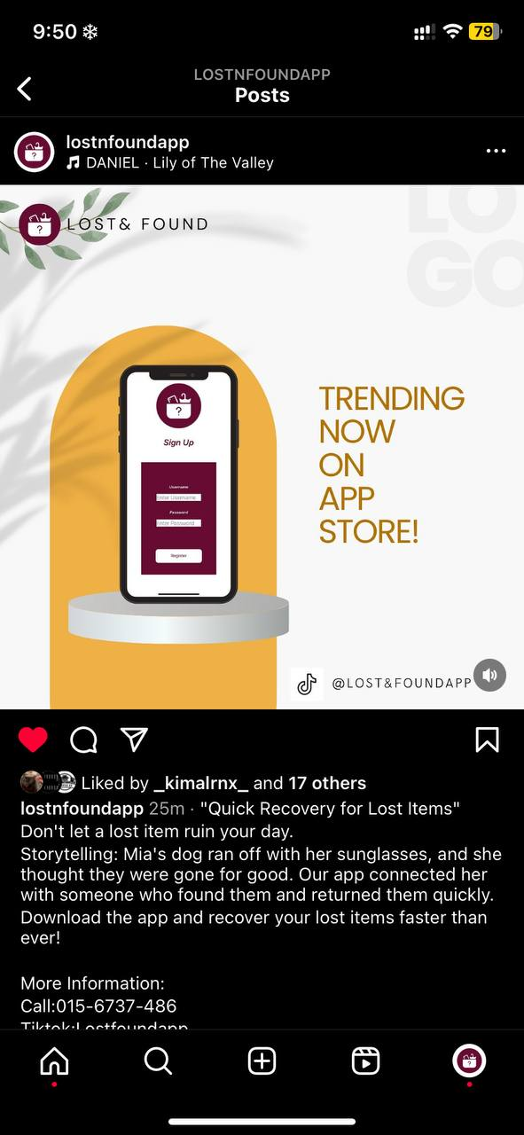

This is my seventh Instagram post, promoting my app, which is currently trending on the Play Store and App Store. Users of Instagram may occasionally see this kind of advertisement and become interested in downloading it due to its viral nature.Additionally, I included a variety of hashtags; the one I underlined is mara.

Eighth Post

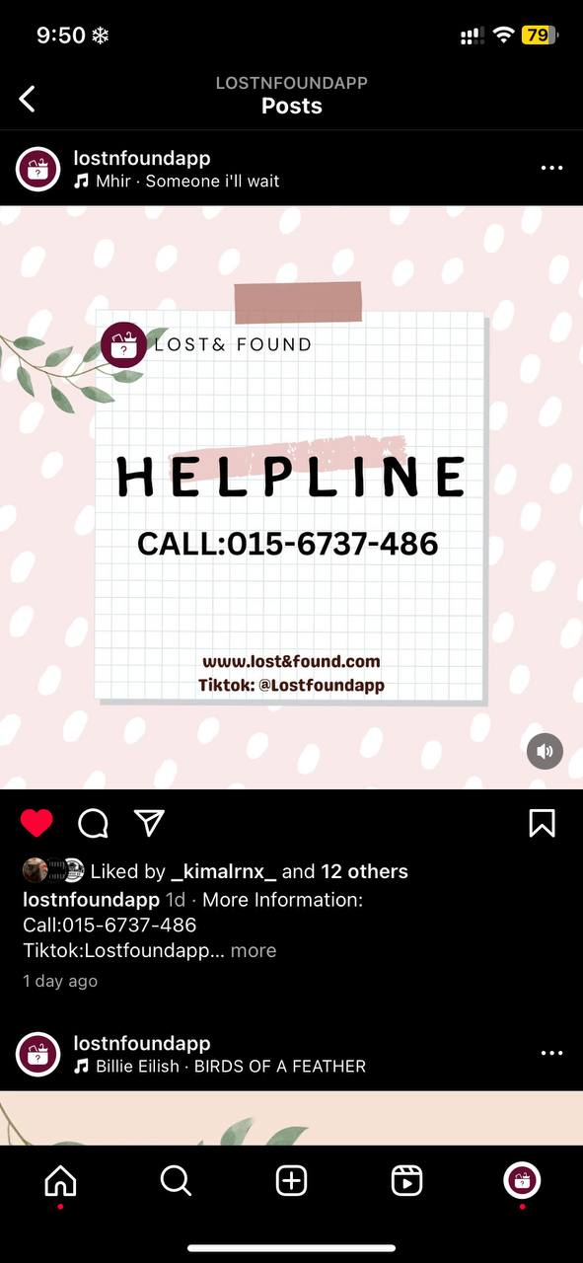

This is my eighth Instagram post, and it contains information regarding my app's detailed helpline in case a user runs into trouble using it.I also included a variety of hashtags, with the one I highlighted being "science," which is how I apply the knowledge I have gained to create this software.

Nineth Post

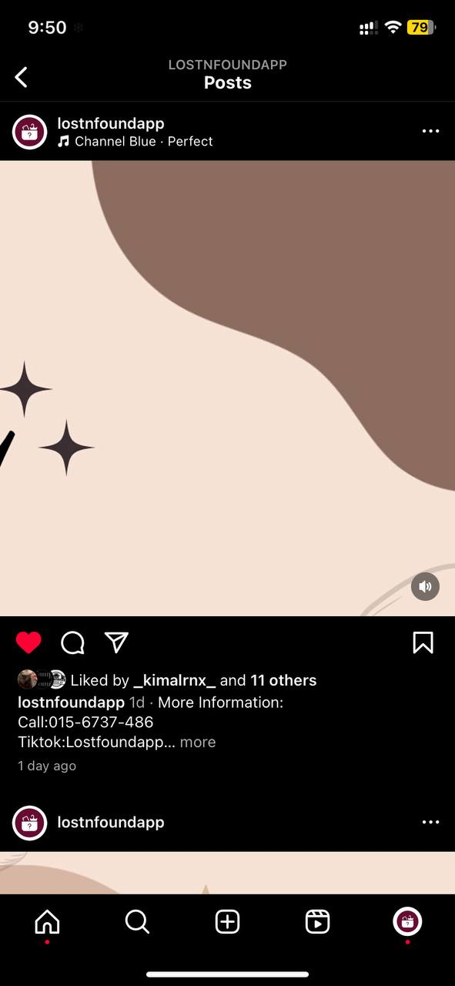

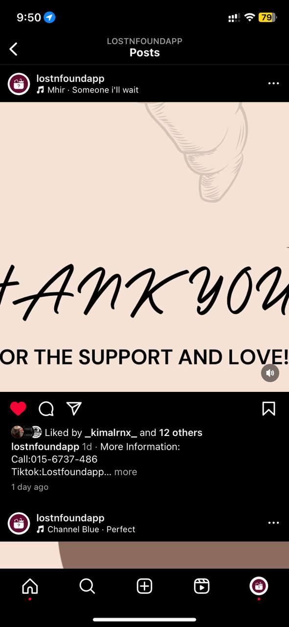

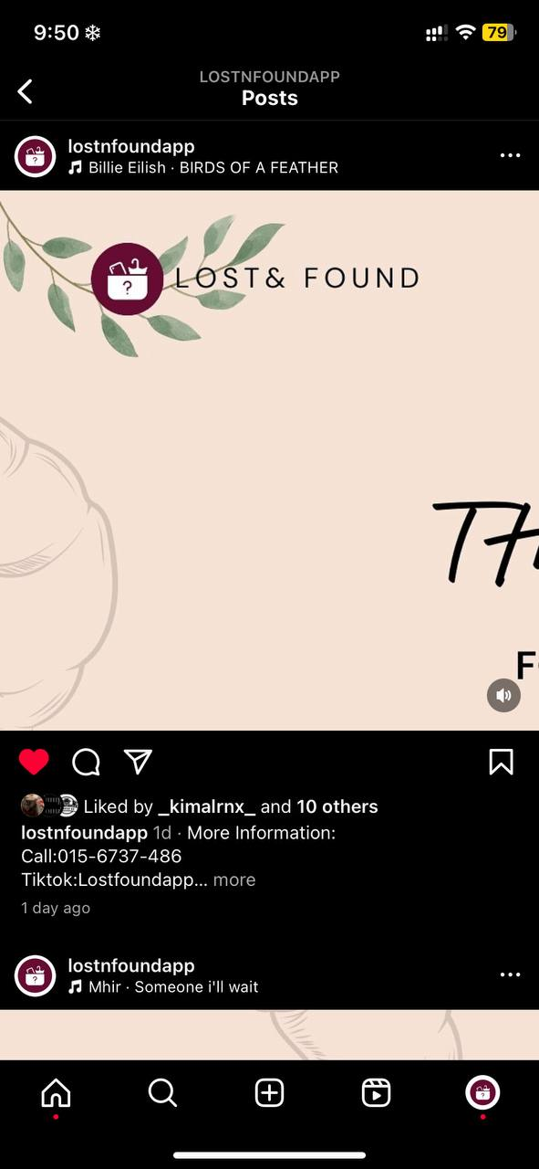

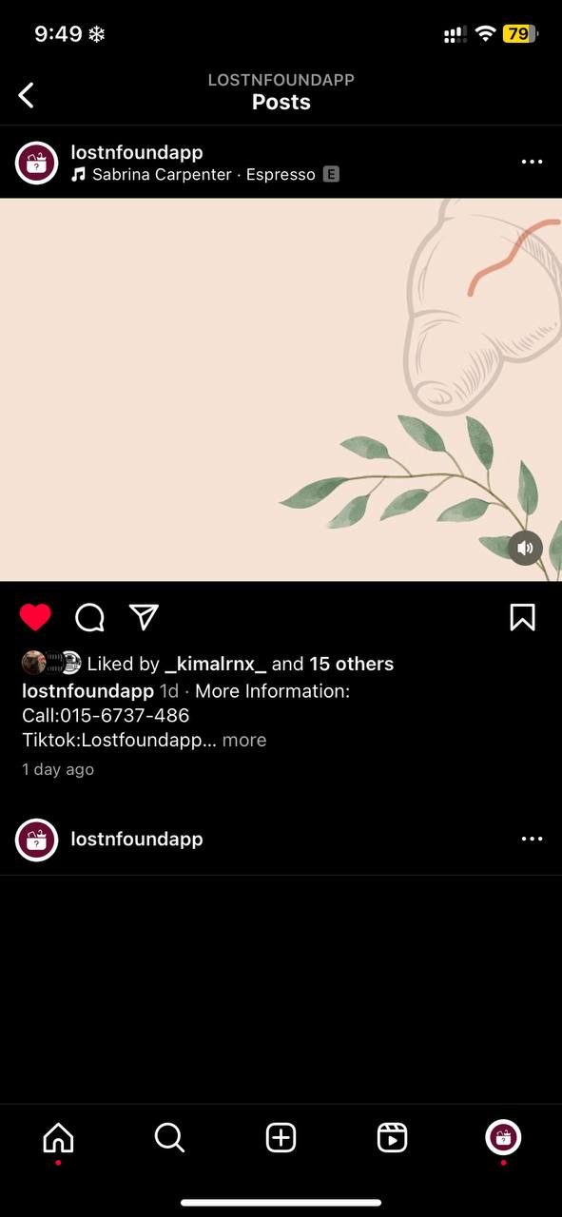

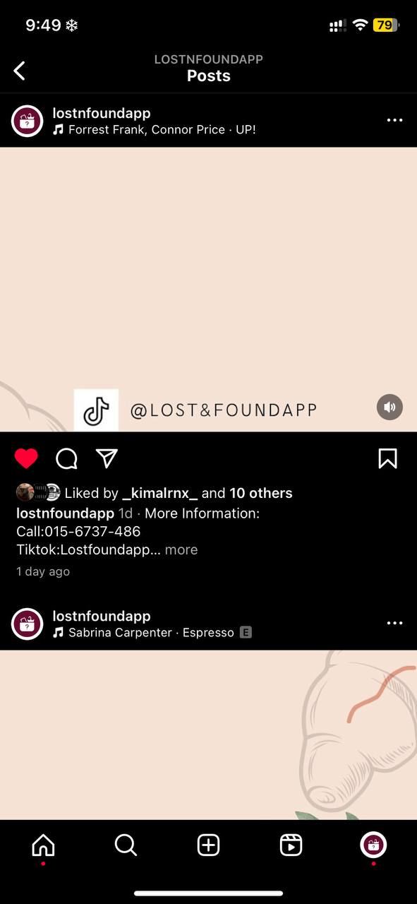

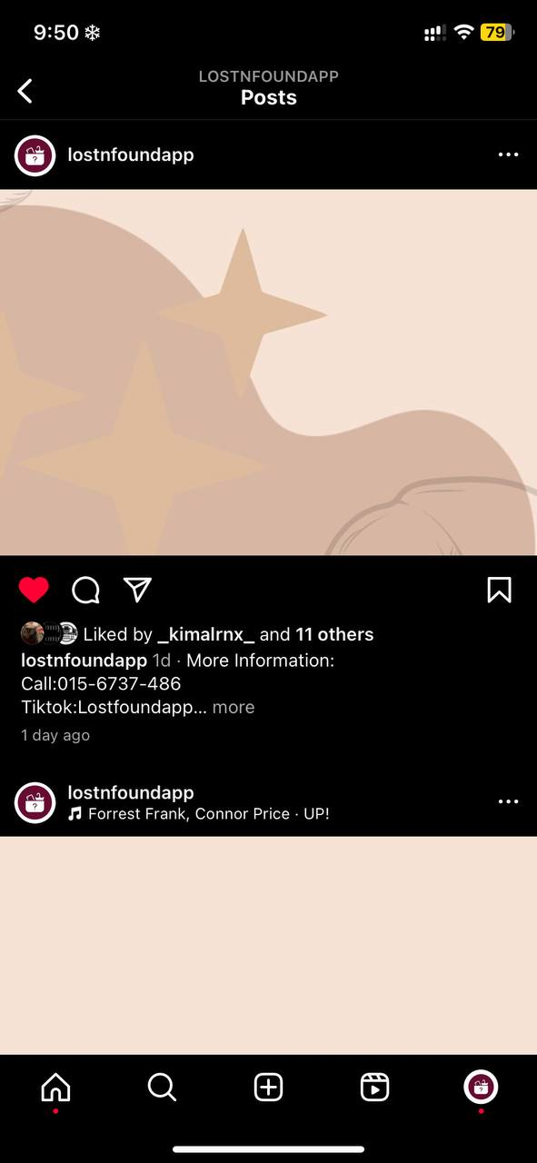

This is my ninth Instagram post, and it's a thank-you note to all the users who have supported me on the platform, including tiktok and Instagram. I've also included a variety of hashtags, but the one I highlighted is "thank you" to express my gratitude to the viewers of the post.

Tenth Post

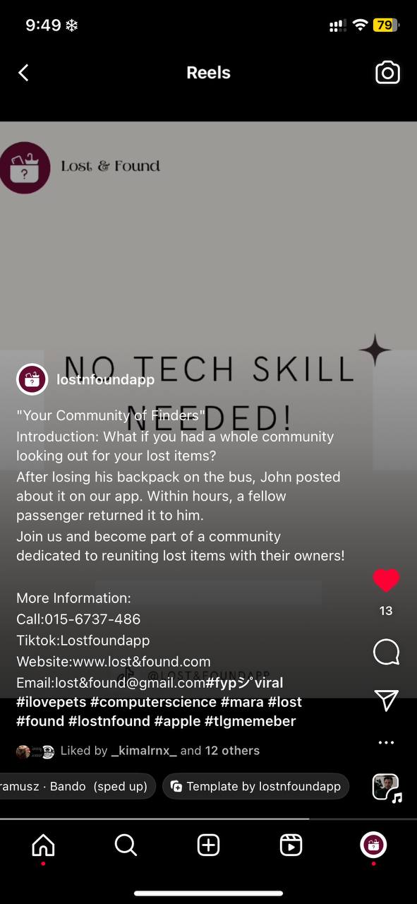

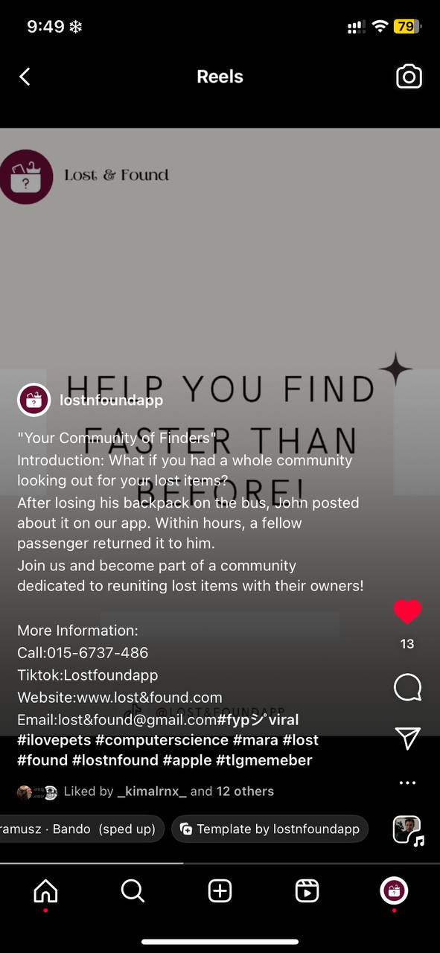

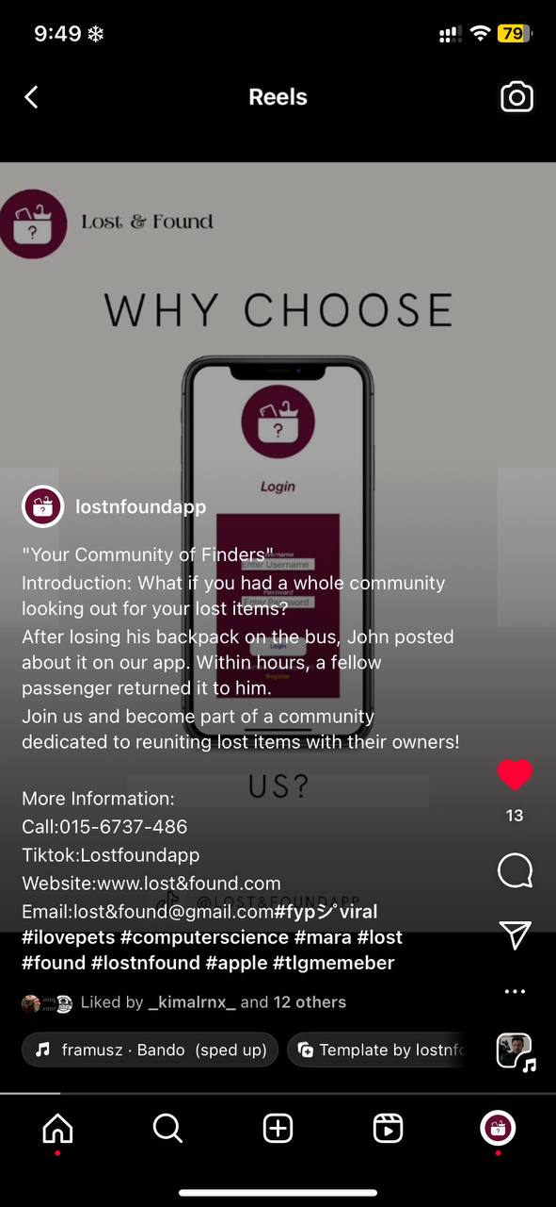

This is my Tenth Instagram post explaining the benefits of downloading the app.In order to draw in users who have been using iPhones, I also included a variety of hashtags, with the one I highlighted being Apple.

Eleventh Post

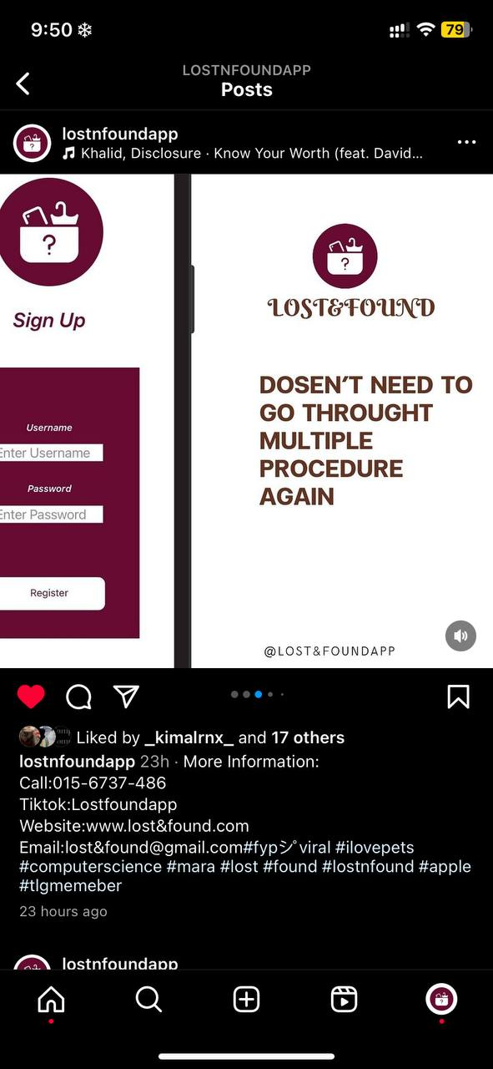

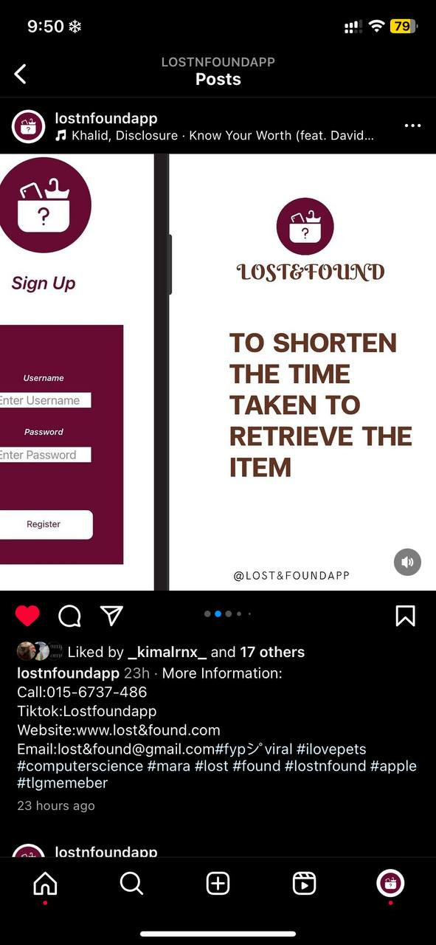

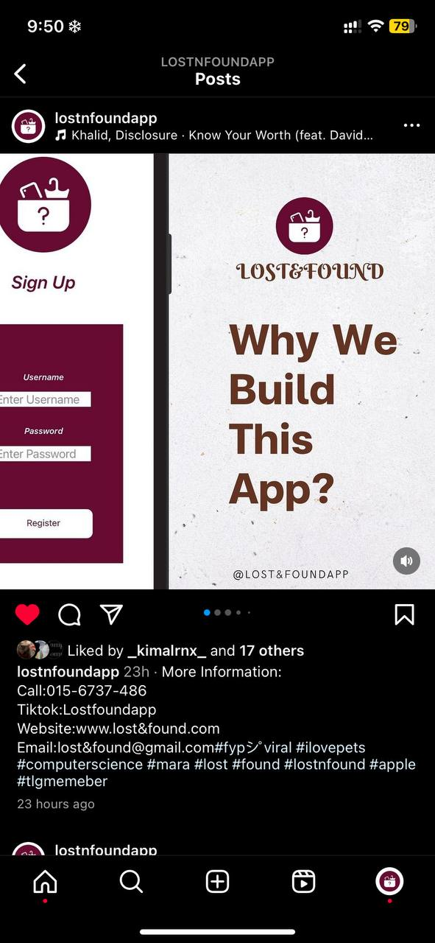

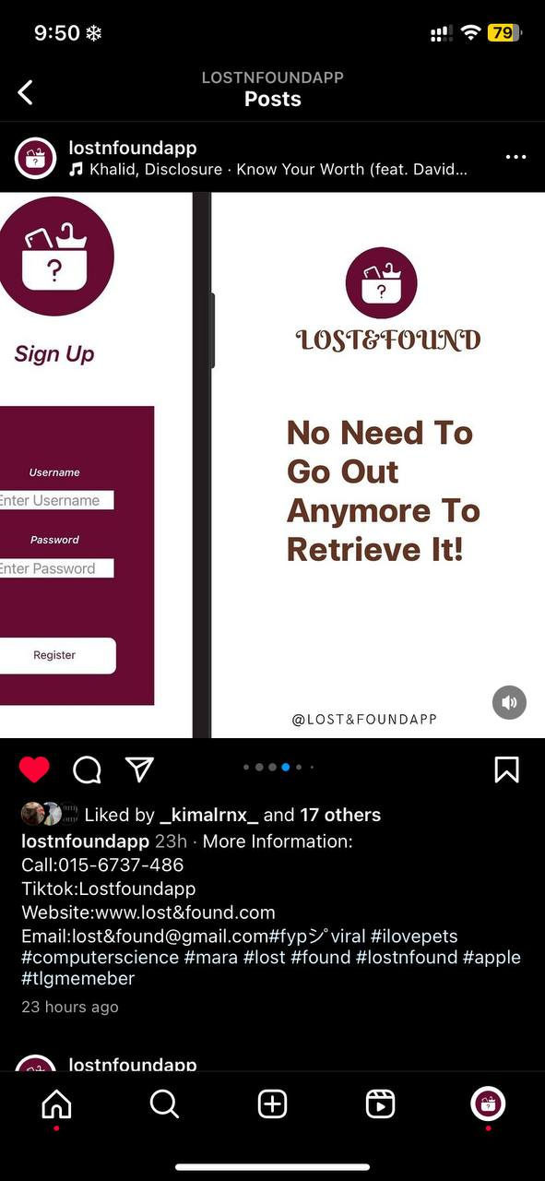

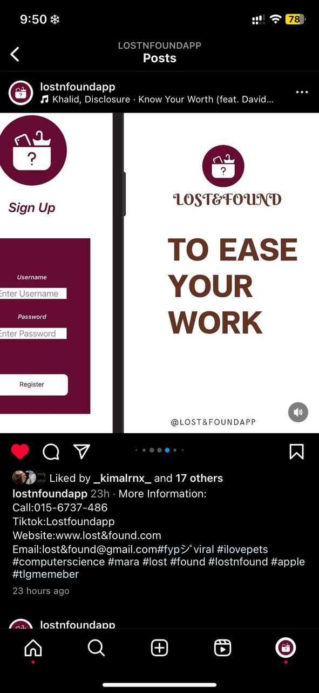

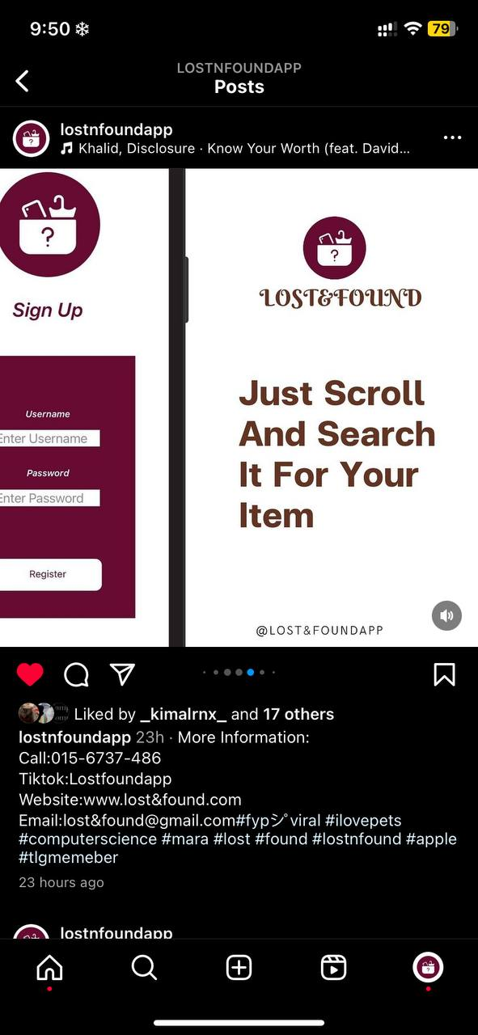

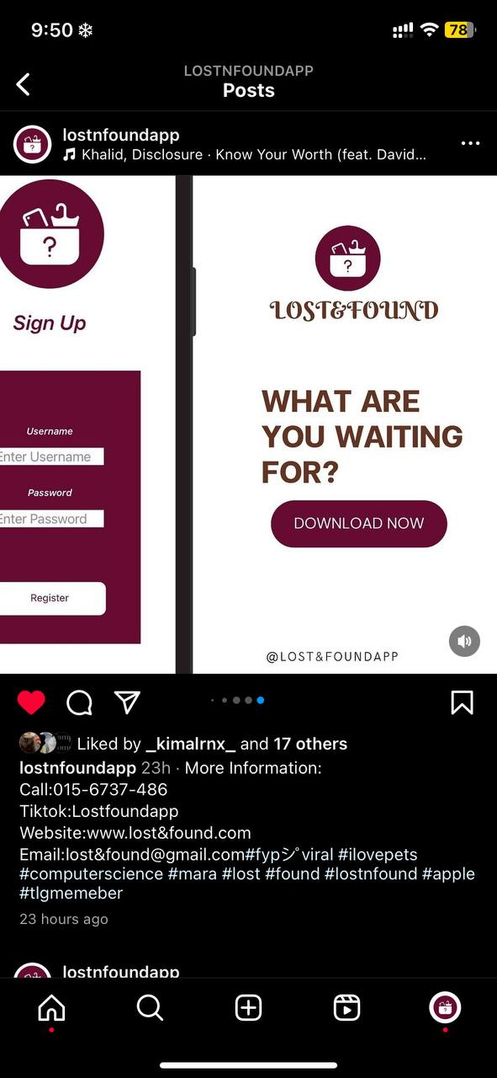

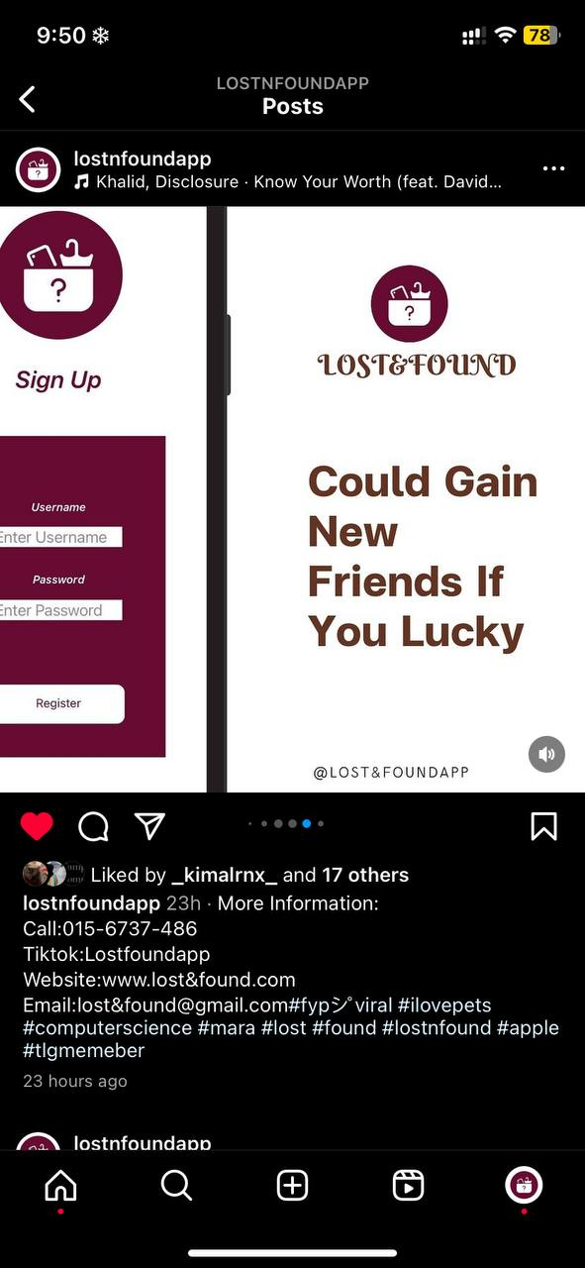

This is my eleventh Instagram post explaining the motivation behind the creation of this app.In order to draw in users and explain to them why I created this app, I also included a variety of hashtags, with the one I highlighted being apple.